<https://tryhackme.com/room/overpass3hosting>

After Overpass's rocky start in infosec, and the commercial failure of their password manager and subsequent hack, they've decided to try a new business venture.

Overpass has become a web hosting company!  
Unfortunately, they haven't learned from their past mistakes. Rumour has it, their main web server is extremely vulnerable.

**Warning:** This box can take **around 5 minutes to boot** if you're not a subscriber. As a subscriber, it will be ready much faster.

I will review writeups for this room starting from 1 week after release. Before then, please do not publish writeups. Keeping them unlisted is fine but please do not share them.

You're welcome to stream this room **once writeups are approved.**  
Banner Image from [Nastuh Abootalebi](https://unsplash.com/@sunday_digital) on [Unsplash](https://unsplash.com/photos/yWwob8kwOCk)

**Enumeration**

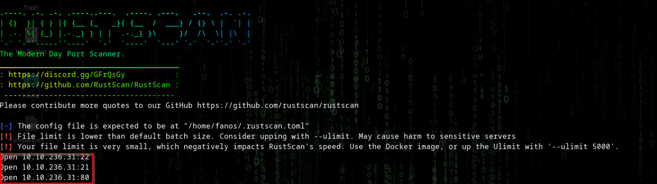

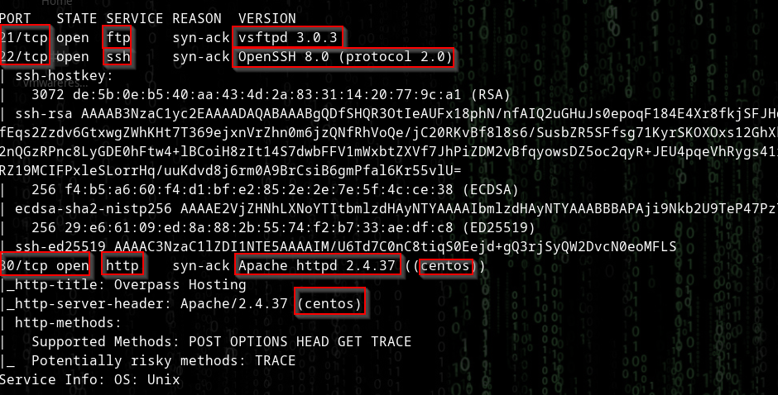

3 ports

**Port 21**

Vsftpd 3.0.3

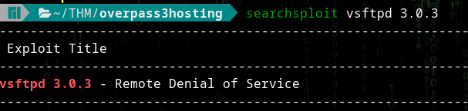

**Port 22**

Openssh 8.0

No exploits found

**Port 80**

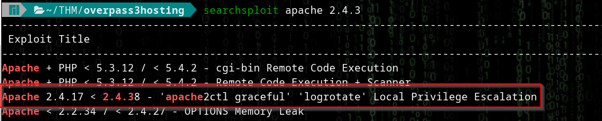

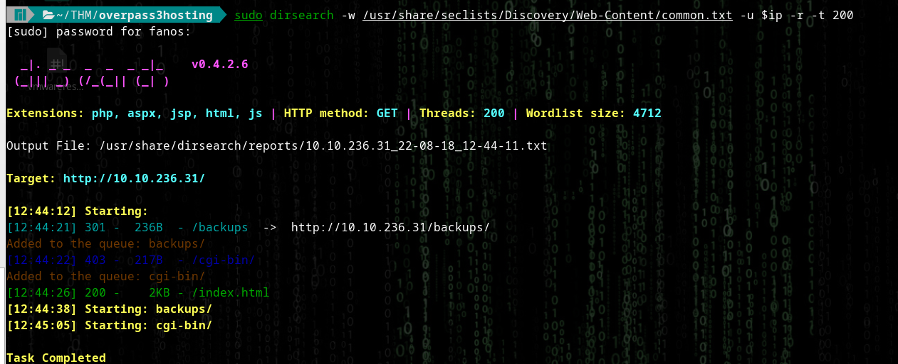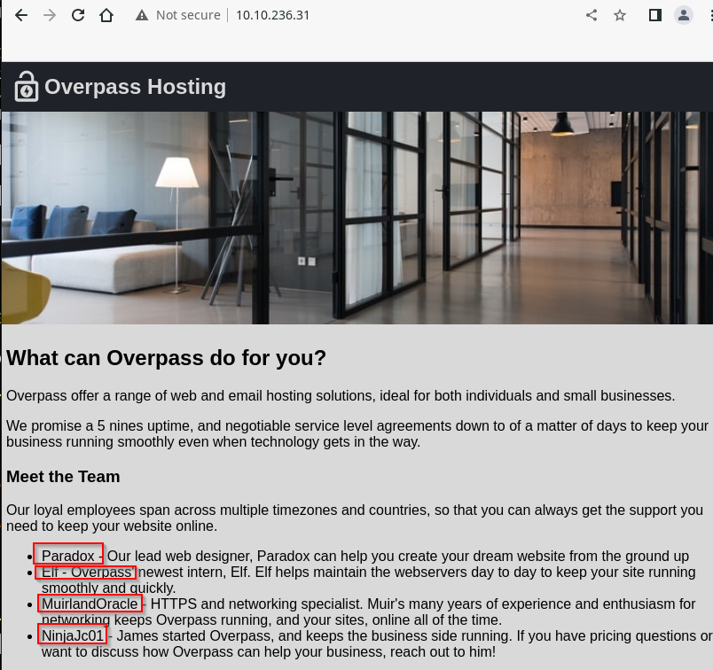

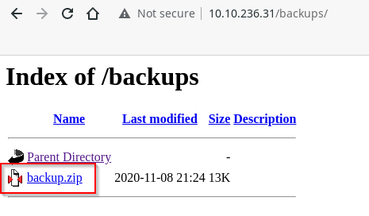

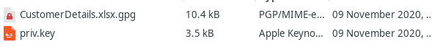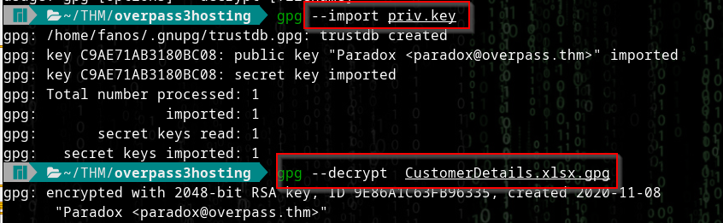

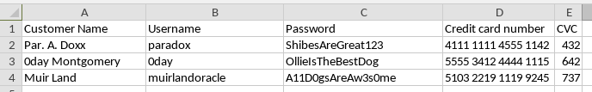

Username paradox

Password ShibesAreGreat123

Username 0day

Password OllieIsTheBestDog

Username muirlandoracle

Password A11D0gsAreAw3s0me

We can use these in ftp

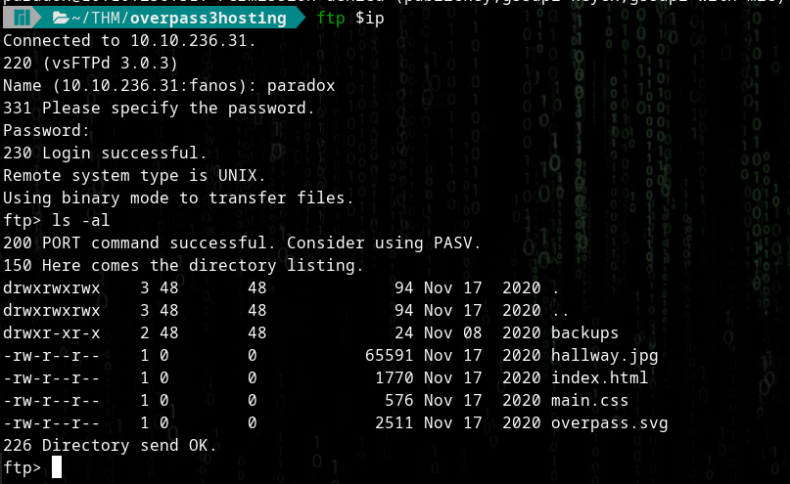

The other fail

SSH fail

I can add files and load them in the browser

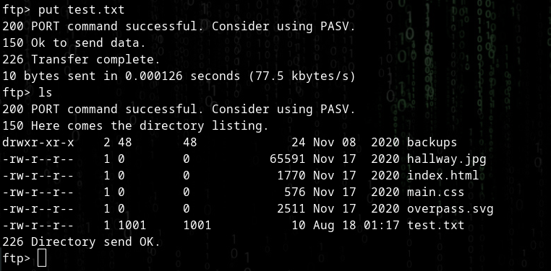

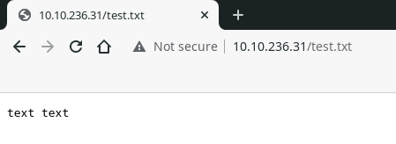

Now to add a php reverse shell

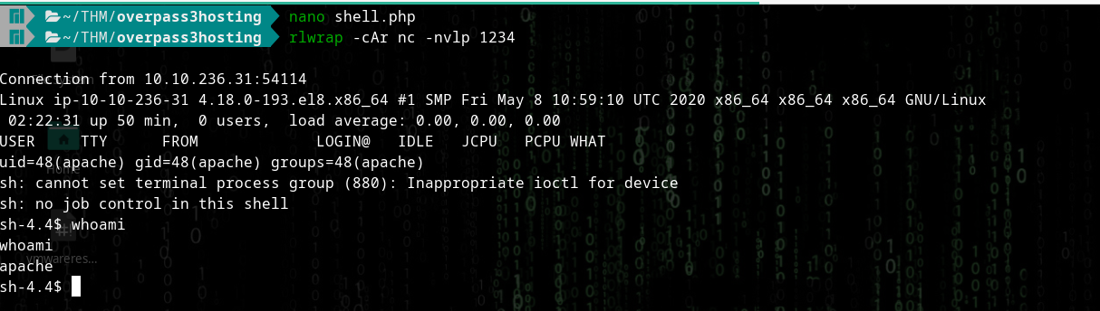

**Priv Escalation**

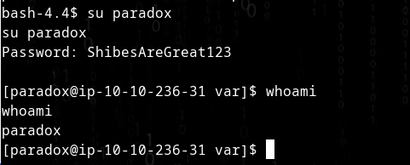

Gain ssh

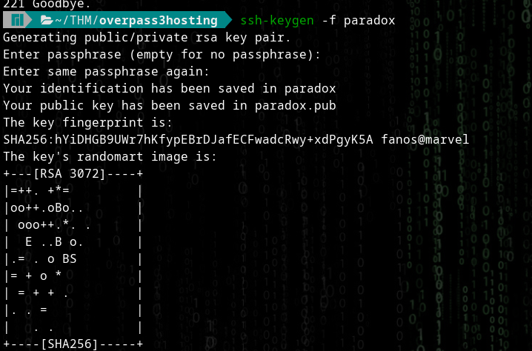



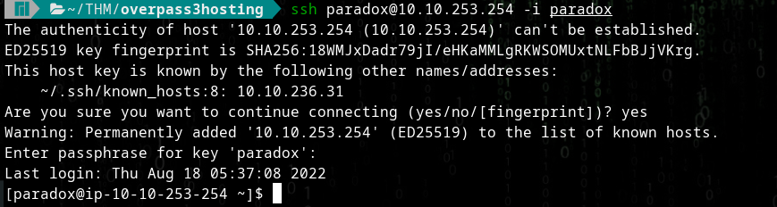

Notice NFS mount???

Try..



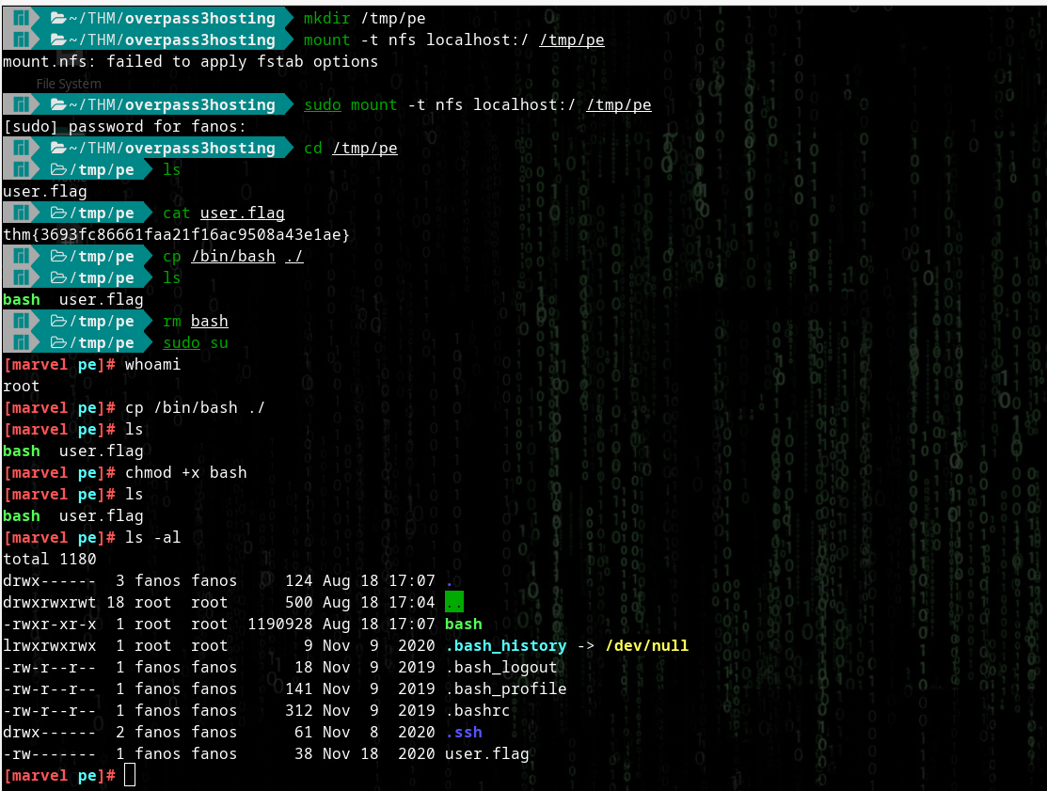

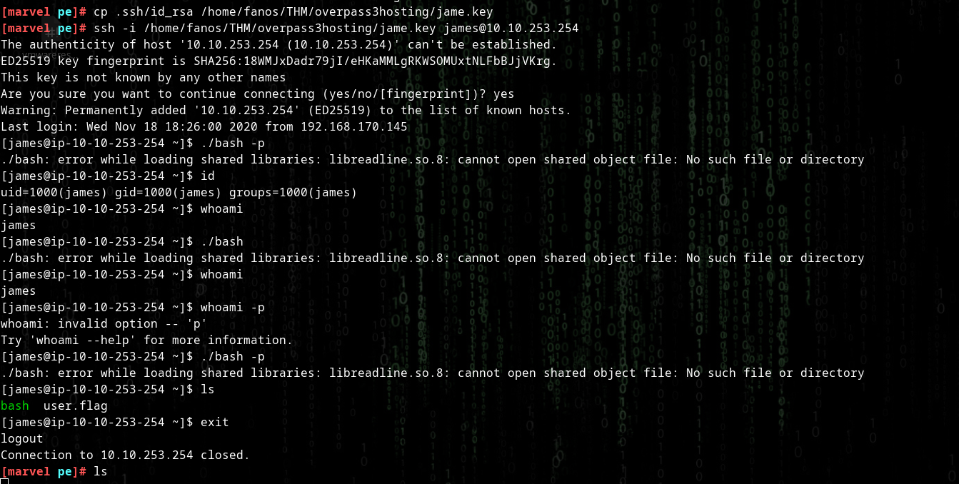

We gain access to James

The system continues to crash and hang. Even when I attempt to run bash

It seems to be an old machine so there may be a problem with that

Ive tried multiple times with the same failed results

For now, I give up

